Meta Title: Risk Management Consulting to help avoid complexities | Call us!
Meta Description: If you need reliable and valuable risk management consulting, reach out to us today. We can save your business from all sorts of potential risks.
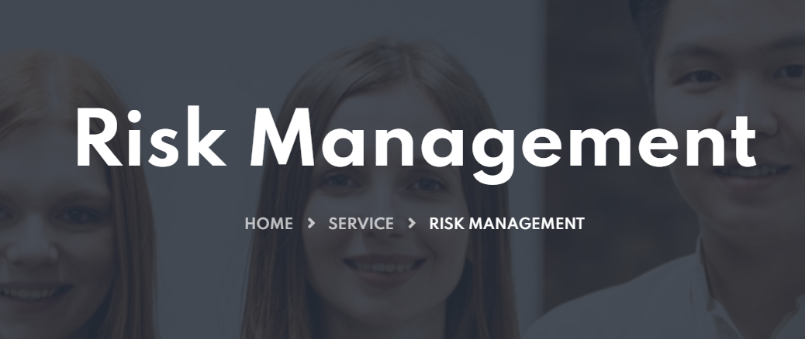

Risk Management Consultancy for navigating Business Dynamics
At The Neo Consultancy, we urge businesses to look at and respond to risk with fresh thinking. Our Risk Management Consulting helps you identify the risks headed your way. Therefore, you can count on us to analyze, evaluate, and report regarding the processes that can deter the safety of the business assets. To put it simply, we help you avert risks by setting strategies that can easily minimize the impact.
Call Today!

Our Risk Management Consulting helps you meet objectives!
With our Risk Management Consulting, your business can effectively respond to change, increase its stakeholder values, and deliver significant growth. Undoubtedly, an unseen risk can affect a business’ ability to meet its objectives. Therefore, it is very important to identify these potential risks and manage them. Our Risk Management Consultants are always happy to help you gain more confidence in business dealings and decisions. After all, we offer you risk-return transparency which is vital for prioritizing risk-inherent business actions. You can count on us to use statistical approaches for determining asset adequacy and help with:
- Risk Strategy Performance
- Cash Flow at Risk Modeling
- Stress Testing
- Compliance Health Checks
- Finance Assessments

Our Risk Management Consulting Includes:
Enterprise Risk Management | Operational Risk Management | Credit Risk Management | Third-Party Risk Management
We give you a risk-informed approach to fit your organization’s needs and expectations. After all, it helps you drive better business performance. | We help you reap long-term and immediate benefits by building an effective Operational Risk Management program for your business. | We help you identify, measure, and manage risks by building an effective credit risk management system, according to the company’s risk appetite. | We help you enhance your business efficiency, visibility, and risk & cost management. For this, we focus on finances, compliance, and technology.
Operational Resilience | Risk and Compliance Analytics | Technology Risk Management | Risk Transformation
Using a strong testing program, we improve the resilience of your company operations across technology, business, cyber, and third-party. | We save you from current and emerging threat vectors and navigate you through a complex regulatory and business environment. | Adopting new technologies increases the chances of risk and exposure. So, we help you design and operate technology models that minimize risks. | You can rely on us to help you design, execute, embed, and sustain risk transformation initiatives that reduce non-compliance and regulatory penalties.

Let our Risk Management Consultants Help you!
Our expert consultants can easily analyze risk from an integrated perspective. If you want to perfectly understand your company’s material risks, allow us to assist you in exploring risk relationships within your organization. No other Risk Management Consulting Firm can outmatch our service standards. From a company beginning the enterprise risk management journey to one with an established framework in place, we assist all of them.

Who needs our Risk Management Consulting Services?
You can benefit from our consultancy if you:
- Run privately held or publicly traded organization
- Want to understand and eliminate potential risks
- Desire to improve current risk management arrangements
- Need to coordinate and formalize risk strategy

What do you get from our Risk Management Consultancy?
- Ability to create enterprise-wide risk aware culture
- Proven process that helps identify and assess risks
- Working risk management and elimination strategies
- Enterprise-wide technology platform assessments
- Perfectly ongoing risk monitory and risk reporting

Experience the best Risk Management Consulting!
At The Neo Consultancy, we understand that risks can come from every angle: upside, downside, and outside. Moreover, these risks can be hard to see and anticipate. Thus, most of the enterprises fail to respond effectively. This is where our Risk Management and Compliance consulting comes in. We help organizations in finding and fixing these risks.
Risk-Return Transparency | We help identify, measure, and prioritize the most important risks along with their returns
Stress Testing | Using a statistical approach, we put your company’s financial backbone to the test
Risk Strategy | We help you strategize on the risks you should be willing to take and risks you must eliminate
Cash Flow at Risk Modeling | We help define the vulnerability scale or your company’s payables and receivables
Compliance Health Check | With our help you understand how your company complies with the current jurisdiction
Finance Assessment | We give you a clear picture of your existing finance operations, openings, and in-between gaps

We can help you excel against all sorts of risks!
With our risk management consulting services by your side, you can tackle today’s risk management challenges and seize tomorrow’s opportunities. After all, we help you confidently navigate dynamic business environments. With our insights and innovative capabilities, you can easily meet tomorrow’s challenges today. So, grow your business without any risk coming the way. Reach out to us today for reliable compliance and risk management service. We are always ready to help you. So, feel free to call anytime.

